Breadcrumbs Development Document

Jonathan Balsano (jrb2194)

Logan Donovan (lrd2127)

Yanyi Luo (yl2504)

Mark Micchelli (mm3710)

*Overall Process*

Each team member came to this project with varying degrees of design and development experience. At the very beginning of the project, Jonathan set up a number of development tools to help us keep our team focused and organized, such as Workflowy for task delegation, GitHub for version control, and CoffeeScript, Backbone, and Underscore for augmenting JavaScript.

**MORE ON GROUP MEMBER ROLES AND DESIGN PROCESS**

The following is our meeting schedule, which we laid out at the beginning of the project, and strictly adhered to throughout the design process. In addition to the meeting schedule, our group was constantly in touch during all hours of the day (and night!) via email and text messaging.

|  |  |
| --- | --- |
| November 26 | Introductions; initial design discussions; review of Yelp bookmarks |
| November 27 | More design discussions; presentation of initial sketches; first drafts of personas and use scenarios |
| November 29 | Completion and submission of personas and use scenarios |
| November 30 | Creation of initial and final markups on myBalsamiq; solidification of design ideas |
| December 2 | Delegation of tasks; tutorials on project tools (Git, Backbone, Underscore, Moustache); start coding the implementation |

*Target Users*

Breadcrumbs is designed for young adults, aged 19-26, who are familiar with technology and live in metropolitan areas. This target user class is largely composed of college students, recent graduates, or individuals of that age. Members of the target user class are typically social, and go out often, engaging with local businesses of a variety of types. Most frequently, they focus on restaurants and bars. However, this demographic also has a tendency to frequent music venues, theaters, and retail stores. These users are educated beyond a high school level, some beyond college. They have a working knowledge of technology and the Internet and frequently turn to such to solve day-to-day problems.

**Persona No. 1: Jeremy the Connoisseur**

Jeremy is a college senior attending school in New York City. He has a deep love for indie style, both in music and fashion. Jeremy is a philosophy major with an interest in film. In particular, he is a film noir enthusiast. In his free time he enjoys going out to bars with a few close friends, reading long dramatic texts, and playing guitar. His family is relatively wealthy, so when he decides to pursue something new, his parents usually foot the bill.

This year, being his final year in college in New York, Jeremy has made a mission of venturing to as many bars as possible before graduating, with the intention of trying a variety of different beers to refine his palate. He has thoroughly enjoyed exploring the bar scene in New York, as well as the variety of brews available, some local, others foreign.

**Jeremy’s Use Case**

Jeremy would like to use Breadcrumbs to keep track of the bars of interest to him as well as the beers they serve. He opens the Breadcrumbs application, which he has been using for some time, selects “My Crumbs” on the top menu, and looks at the lists of places he has currently bookmarked. He currently has a few lists: “Bars I’ve been to”, “Bars to try”, “Lunch Spots”, “Great Concert Venues”, and “Restaurants with Beer”. Today he’d like to finally sort out all the information he’s compiled on each bar and restaurant to sort out where he can get the best beers. He starts by clicking on the “Add List” picture on the “My Crumbs” page, to create a new list called “Favorite Beer Spots”. Then, Jeremy returns to the list menu by selecting “My Crumbs” in the breadcrumbs[1] at the top of the page. Next, he opens the list “Bars I’ve been to” by clicking on its image stack. He then starts scrolling down the list, viewing his notes for each bar by hovering his mouse over the “notes” icon underneath each business. If his notes indicate that he enjoyed the bar, Jeremy clicks on that bar’s “lists” icon to see the lists that bar belongs to. To add that bar to his “Favorite Beer Spots” list, he simply clicks the checkbox next to “Favorite Beer Spots”. When he’s finished looking through his “Bars I’ve been to” list, he returns to the “My Crumbs” page by using the breadcrumbs, and then moves on to his other lists to repeat the process. Once he’s done, he closes the app.

A few days later, Jeremy receives a call from a friend who says she’d love to visit on her way home from England when her flight lands in New York. Jeremy decides he’ll have to take her to a bar to try some of the best beers he’s found. Being that she’s spent the past year in England, he thinks a bar with a great local brew would be the best choice. He turns to the Breadcrumbs app, goes to “My Crumbs”, and opens up his new list of “Favorite Beer Spots”. He then glances down the list of his notes by hovering his mouse over the notes icon underneath each bar. He spots a restaurant on which he noted “Best Brooklyn Beer I’ve had yet” and decides that’s where he will take her. Having found the information he sought, Jeremy closes Breadcrumbs.

**Persona No. 2: Amanda the Blogger**

Amanda is a recent college graduate living in New York City. As a journalism major, she writes random bits for a variety of publications to make ends meet while she searches for a full time job. Amanda is a brunch-lover, the kind of person whose first response when looking to meet with someone is “let’s do brunch!” She enjoys well-crafted food, and will often go out of her way to seek it out. Aside from her writing, she practices yoga three times a week, volunteers at a nearby animal shelter, and occasionally hosts dinner parties.

Currently, Amanda is working on a new project: a food blog. With all the brunch and dinner parties she hosts, and her expert writing skills, she feels that starting a food blog is a great way to showcase her talent and generate some buzz around her name. Unfortunately, she eats out so often that she can’t write fast enough about all the food she’s tried. Instead, she tries to pick the best and worst from each week and only write about those.

**Amanda’s Use Case**

Amanda decides she needs a better place to keep track of all the food she’s tried. Previously she’s kept a journal after each restaurant trip noting what food she’s eaten and a few short notes. Breadcrumbs seems like a great tool to use for this purpose so she decides to give it a try. Opening up the app for the first time, Amanda clicks on “+ Add Crumbs” to search for the restaurants she wants to bookmark. She sees the “Search Yelp” bar, and types in the name of her favorite restaurant in Greenwich Village. This brings her to a search results page, which shows her the restaurant she’s looking for. Amanda notices the “add bookmark” icon underneath the picture of the restaurant, and then clicks on it to add it to the Breadcrumbs app. Amanda returns to the “Add Crumbs” page by clicking on the link at the top of the app, and then repeats this process with her other favorite restaurants.

After Amanda pulls all of her bookmarks from Yelp, she realizes that her bookmarks are unorganized, with restaurants she’s reviewed mixed in with ones she hasn’t. Amanda decides she wants to organize all of her bookmarks into two lists, one for reviewed restaurants, and one for unreviewed restaurants. She goes to the “My Crumbs” page by clicking on the “My Crumbs” link at the top of the app, and sees an image labeled “Add List”. She selects the image twice to create two lists, which she calls “Reviewed Restaurants” and “Unreviewed Restaurants.” To populate these lists, Amanda selects “All Crumbs” from the “My Crumbs” page, and starts clicking on each restaurant. Every time she does this, Breadcrumbs opens up the single item view page, which has an icon labeled “lists”. For each restaurant, Amanda clicks on this icon, which opens up a section where she can add or remove the restaurant from her three lists: “All Crumbs”, “Reviewed Restaurants”, and “Unreviewed Restaurants”. Then, Amanda selects the appropriate list to add the restaurant to, and returns to the “All Crumbs” list by selecting “All Crumbs” from the breadcrumbs at the top of the page. Once she’s done this for all of her bookmarks, Amanda double-checks that her “Reviewed Restaurants” and “Unreviewed Restaurants” lists display the appropriate information. Satisfied, she closes the Breadcrumbs app.

The next day, Amanda decides to start knocking out all the restaurants she never reviewed, so she opens up the app to the “My Crumbs” page, and is confronted with her two lists. She selects her “Unreviewed Restaurants” list and browses through the list to decide which two she will review. Finding the brunch spot from two days ago, and dinner from a week ago, she keeps the restaurant information open on Breadcrumbs, and proceeds to write her blog post. When finished, she closes the Breadcrumbs app.

*Design Decisions*

The following are some important design decisions that faced our team. They range from core functionality concerns to minor aesthetic choices, but they all required thorough discussion .

Levels of Categorization: Bookmarks, Lists, Tags, Categories, Crumbs?

During our first meeting, our team discovered a number of ways to organize business in Yelp. Yelp has separate sections for bookmarks, lists (which are completely independent from bookmarks), tags, and search categories. Towards the beginning of the project, we spent some time trying to include all of these distinctions in our own app, but we eventually decided in favor of simplicity. Breadcrumbs app can pull businesses from the Yelp website to bookmark them, and then the user can sort these bookmarks into lists. To search for a specific bookmark, users can filter their lists using categories drawn from the Yelp API. This design is so simple that we were able to create a fully functional, better-than-Yelp bookmarking system with only five distinct markups on myBalsamiq.

Another design decision we made

The Crumb Icons: the Functional and the Aesthetic

Our team wanted an easy way for the user to know the *complete* set of actions she can .

For example, when viewing a list of businesses, each business contains four icons that describe the *complete* set of actions the user can do with that business. While we also have a single-business view, which is slightly less cluttered and more detailed, you actually never need to use that if you don’t want to. This decision is in line with the sixth usability heuristic: recognition rather than recall. Because

Everything is visible

*Prototyping*

Our prototyping began with sketches drawn up by Jonathan and Yanyi. Remarkably, their sketches, created separately, turned out to be nearly identical. We then set to work copying the hand-drawn sketches into myBalsamiq. This initial foray into myBalsamiq familiarized each team member with the overall app design, and also highlighted early, obvious design flaws and mistakes, which were soon eliminated. After this step, our group took a short break, and then critiqued each of the five markups in turn. This helped us solidify our ideas, and after some debate and discussion with our group members, we ended up with a final design that we were all proud of.

Here are Jon’s original sketches, which were made into myBalsamiq markups:

**PUT PICTURES HERE**

Here are our five myBalsamiq markups in their initial and final versions, with comments to show how our group improved on each markup with discussion and compromise.

**Lists View, or My Crumbs**

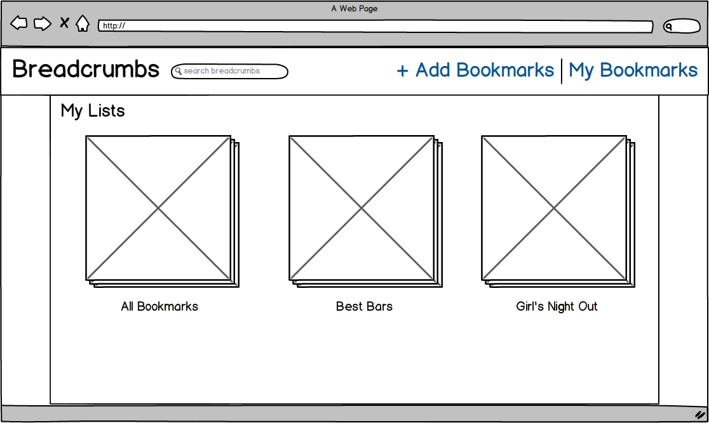

This is the initial markup of the lists view, which appears whenever the user clicks on “My Bookmarks”. We decided here that the first list that should appear is the list of “All Bookmarks”, which is the master list that contains all business loaded into the app.

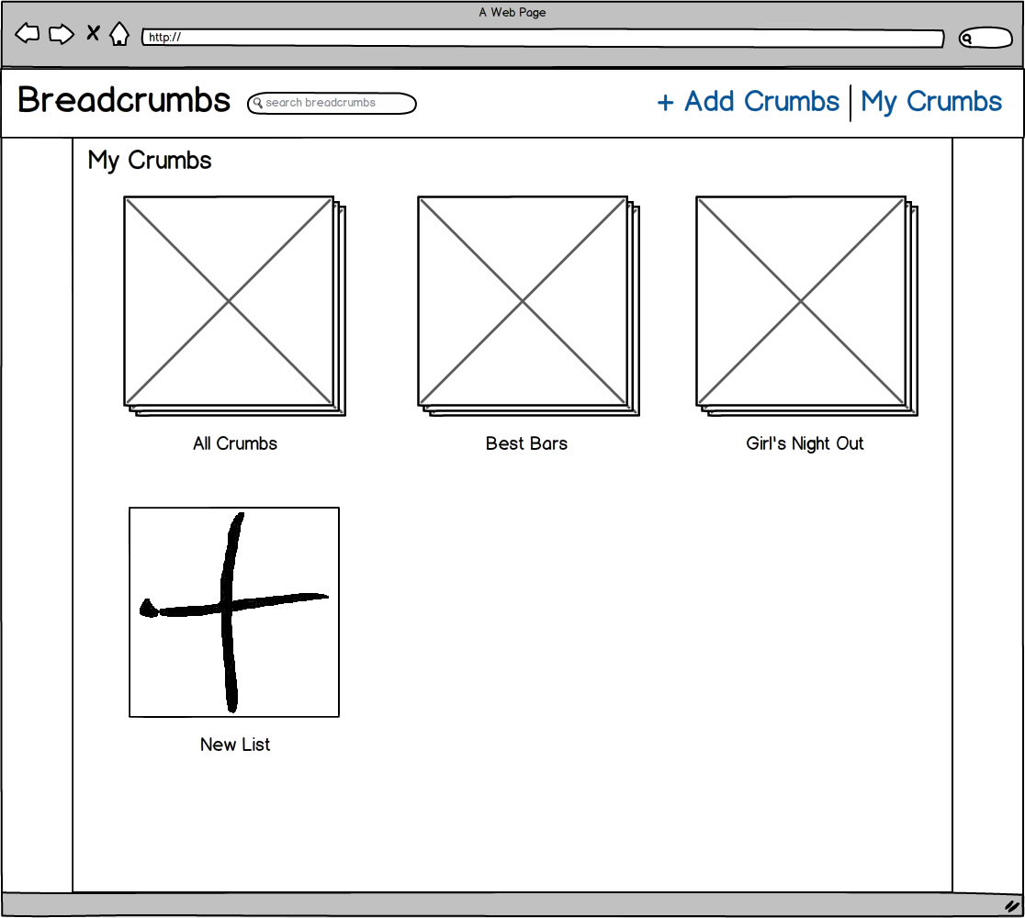

This is the final markup of the lists view. We wanted an easy way for the user to create a new lists, so at the end of the list of lists, we added a big “plus” icon to show the user how to add a new list. We also decided here to change the terminology from “Bookmark” to “Crumb”, in order to give the app more character and name recognition. This change is reflected in all subsequent final markups.

**Browse View, or Add Crumbs**

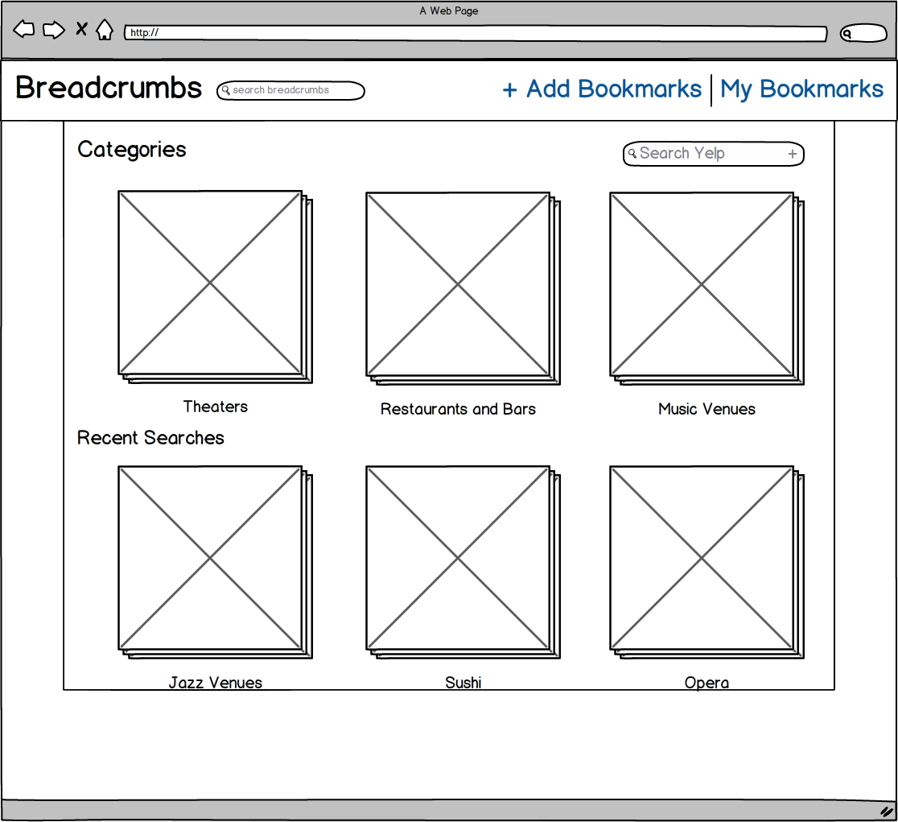

This is the initial markup of the browse view, accessed by clicking “Add Bookmarks”). It does not show the toolbar that appears when you click the box labeled “Search Yelp”.

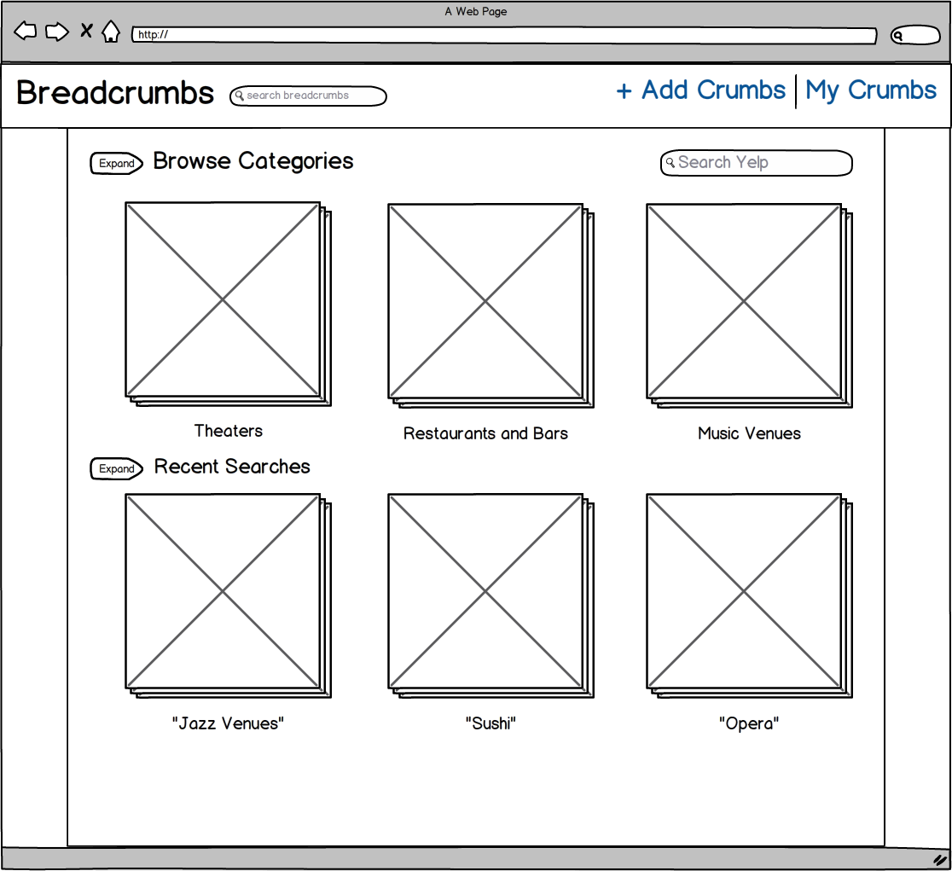This is the final version of the browse view. As you can see, we added “expand” arrows to the “Browse Categories” and “Recent Searches” sections, because we wanted a way to show more results than pictured here. Horizontal scrolling was also discussed as an option, but it was ultimately vetoed because of some group members’ dislike for the feature.

**Single List View**

This 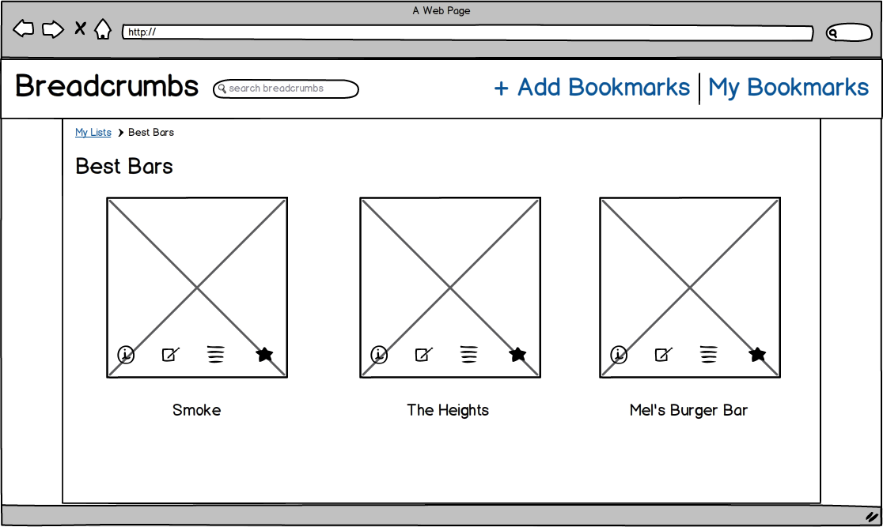is the initial markup of the single list view, showing a list called “Best Bars”. Each list can be accessed from the “My Bookmarks” page. The four icons over each picture have the following meanings: info, notes, list membership, and reviews. By hovering the mouse cursor over any of these icons, the app will replace the picture of the business with the corresponding information. Furthermore, by clicking on any of the icons, the selected information will freeze in place of the picture.

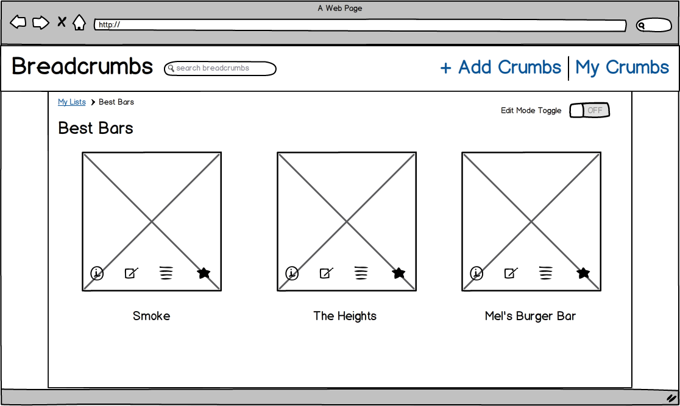

This is the final markup for the single list view. The only change we made was a toggle that switches the list in and out of “edit mode”. The “edit mode” feature allows the user to reorder and delete crumbs from the list.

**Search Results View**

Th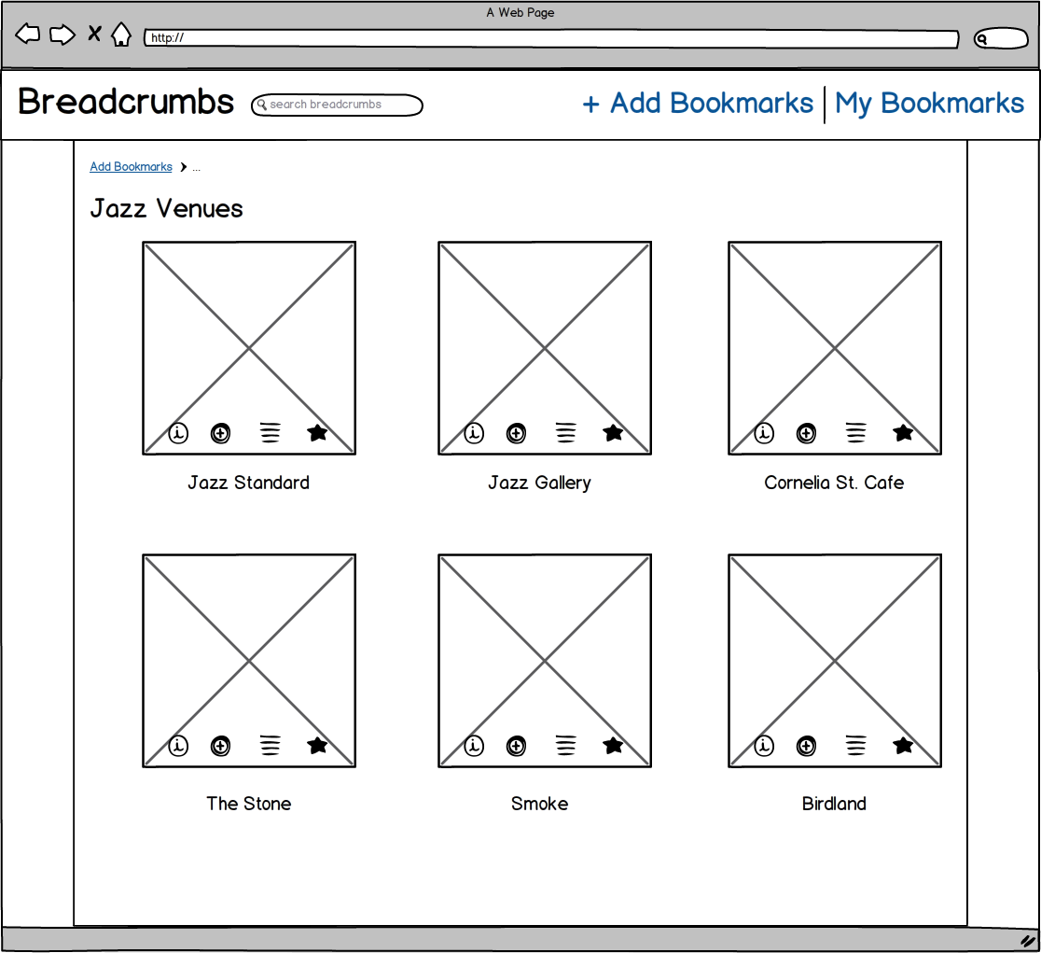is is the page that appears whenever you search for something in the “Add Bookmarks” page. This markup shows the results for the query “Jazz Venues”. The four icons here are info, add bookmark, list membership, and reviews. (The same as in the single list view, but with “add bookmark” in place of notes.) The hovering and clicking features are the same in this page as they are in the single list view page, creating consistency across our app.

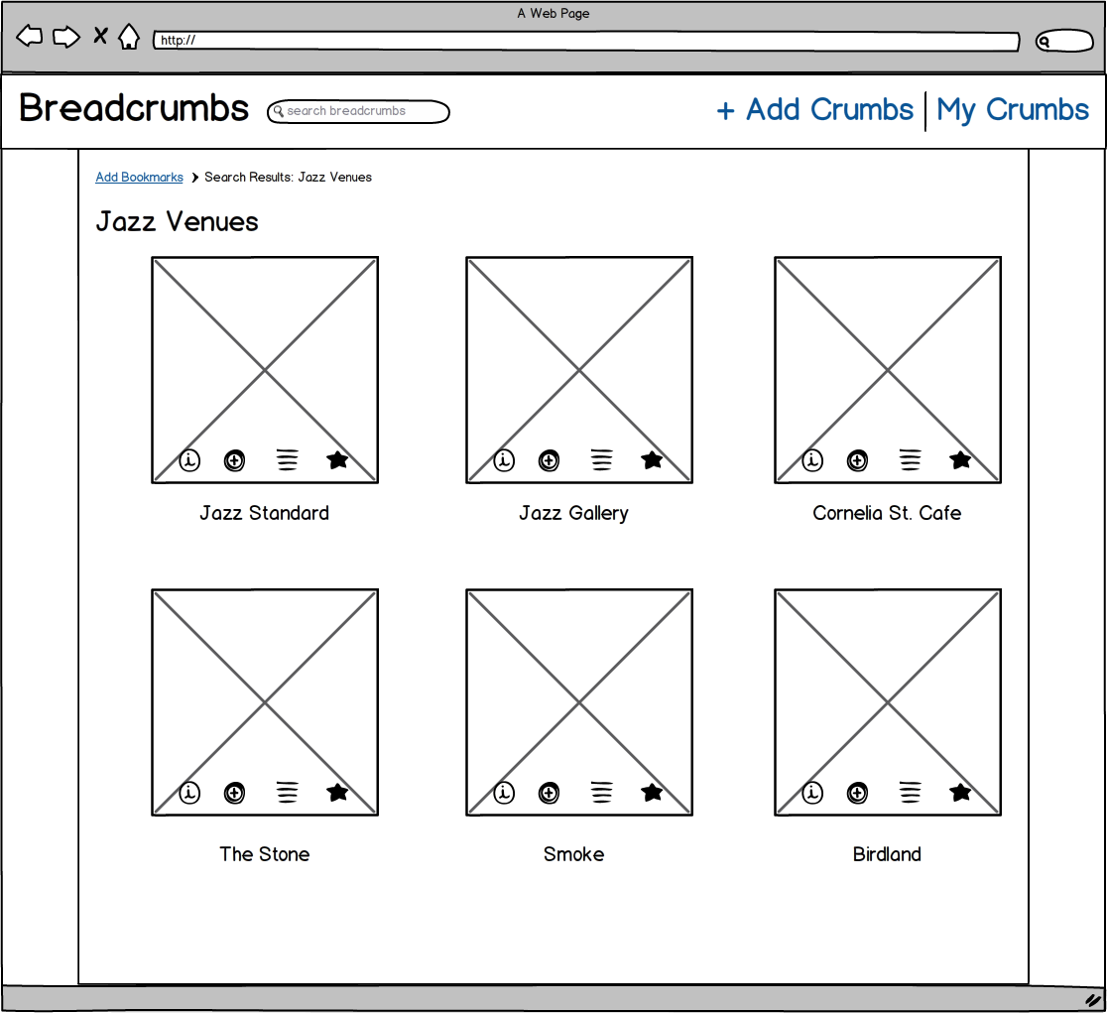The final markup here is almost identical to the initial one. The only change is that we fixed the site map functionality at the top of the page. (Coincidentally, this site map feature is itself called “breadcrumbs”—no relation to our app.) This clearer site map helps our app more closely adhere to the third usability heuristic: user control and freedom. The user knows exactly how she got to this page in the app, and can easily return to the previous page if she found she made a mistake.

**Single Item View, or Crumb View**

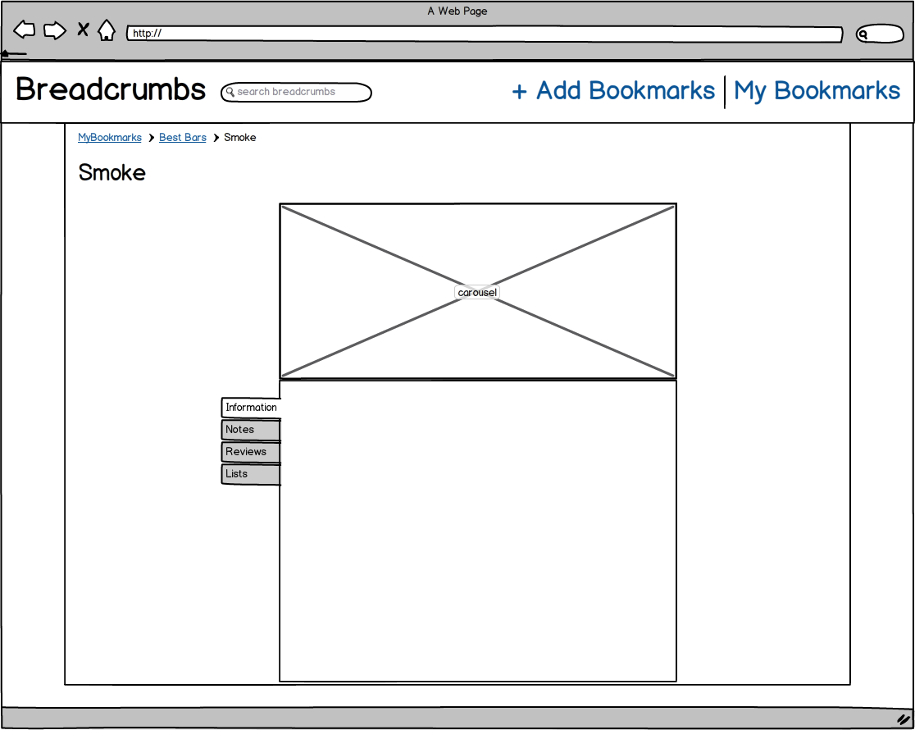This is the initial markup for the page that appears when you click on a crumb in one of your lists. As you can see, it contains tabs that correspond to each icon in the list view. It also contains a larger picture, and more space to read about the information, notes, lists, and reviews.

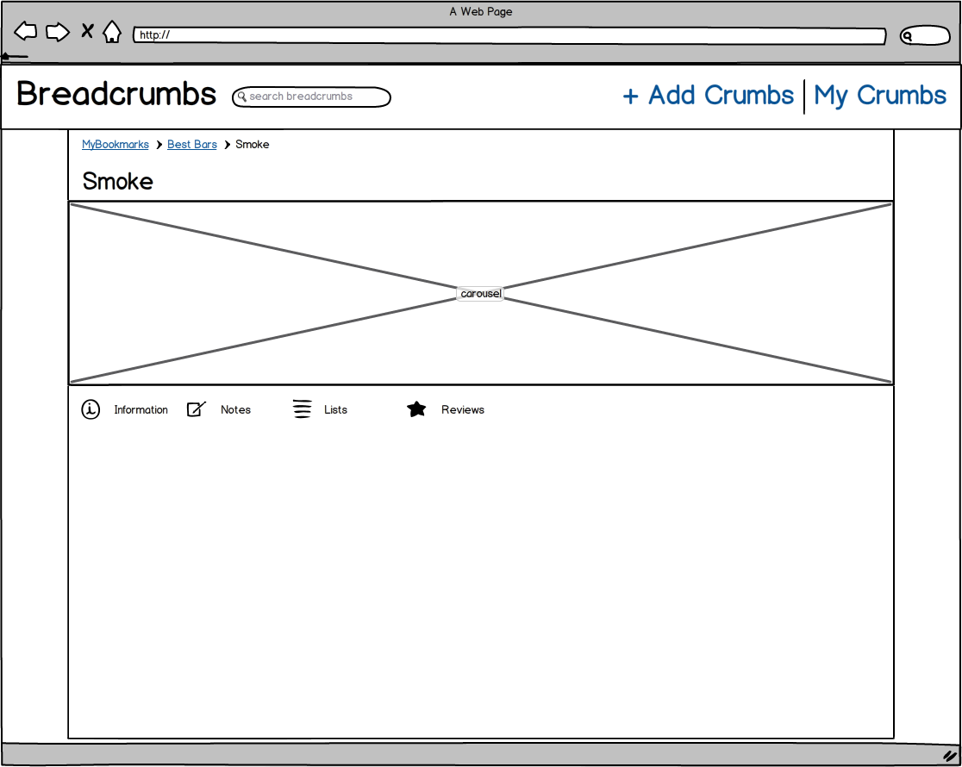

This is the final markup for the single item view. We increased the size of the picture, and also decided to use icons instead of tabs in order to switch between the information, notes, lists, and reviews sections. This decision made our app more consistent, as now every function is mapped with the same icon throughout every page in our app. This follows the fourth usability heuristic: consistency and standards. Each icon in each page does exactly the same thing as identical icons on different pages, and there is exactly one icon to represent each Breadcrumbs function.

*Testing Process*

To aid our testing process, Yanyi suggested using an app called InVision. InVision is a mockup application that actually lets you simulate .

Since our target class of users was

1. Please note that, as used here, “breadcrumbs” refers to the list of pages a user has been through to get to his current location, as often displayed at the top of webpages. This is a technical term that has no relation to our Breadcrumbs app. From this point on, assume that lowercase “breadcrumbs” refers to this list of pages, while uppercase “Breadcrumbs” refers to our app.